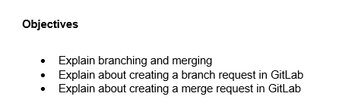

* Branching in Git allows developers to diverge from the main codebase to work independently on features or fixes. It enables parallel development without affecting the stable code.

Merging is the process of integrating changes from one branch into another, typically from a feature branch into the main branch. This ensures all contributions are consolidated. It is fundamental to collaborative version control.

* In GitLab, creating a branch involves initiating a separate line of development within a project repository. This can be done through the GitLab web interface or via Git commands. Developers create branches to isolate feature development or bug fixes. After pushing the new branch, it becomes available for collaboration. It facilitates organized and modular contributions.
* A merge request in GitLab is a formal proposal to integrate changes from one branch into another, commonly from a feature branch into the main branch. It allows team members to review, discuss, and approve changes before merging. Merge requests promote code quality and collaborative review processes. They can be created through the GitLab interface after pushing the branch. This ensures transparent and controlled code integration.

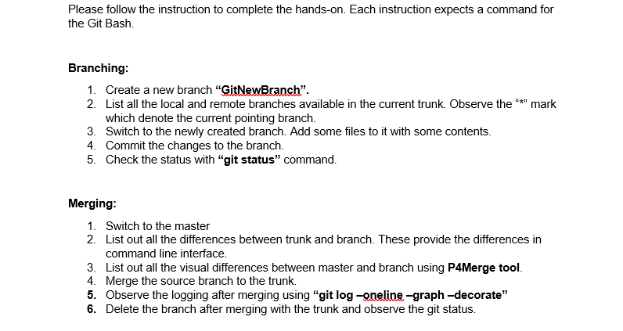

**Solution**

**Branching**

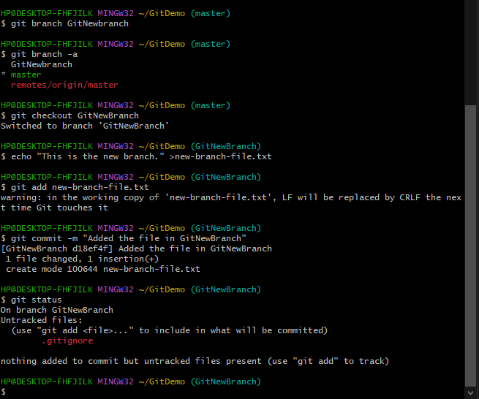

**Merging**

